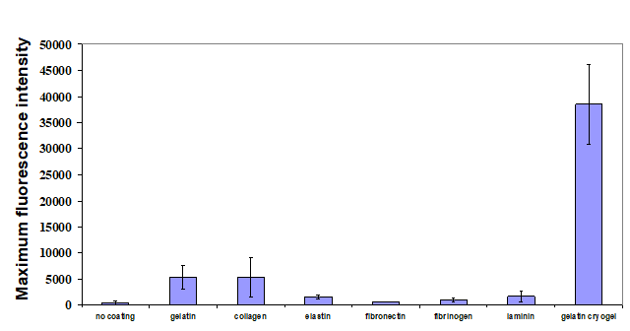

Figure S1. A graph summarizing the average of maximum fluorescence intensity in a field (n = 3–5 pictures). Representative micrographs were analyzed using Fiji/Image J’s “Analyze”→”Measure” function to calculate maximum fluorescence intensities for each image.

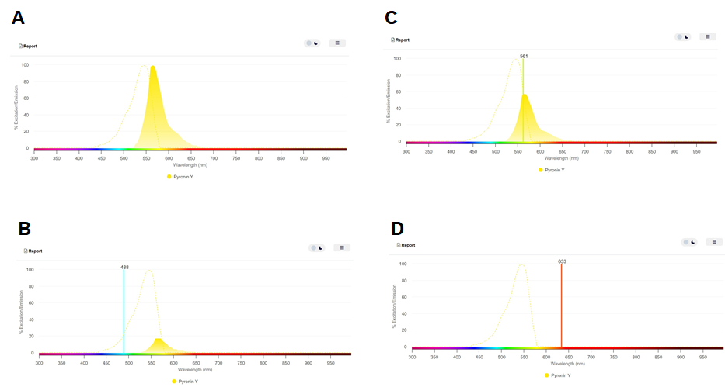

Figure S2. The comparison of pyronin Y (A) excitation (dotted line) and emission spectra (solid line) data with three laser lines (488, 561, and 633 nm; B–D)

